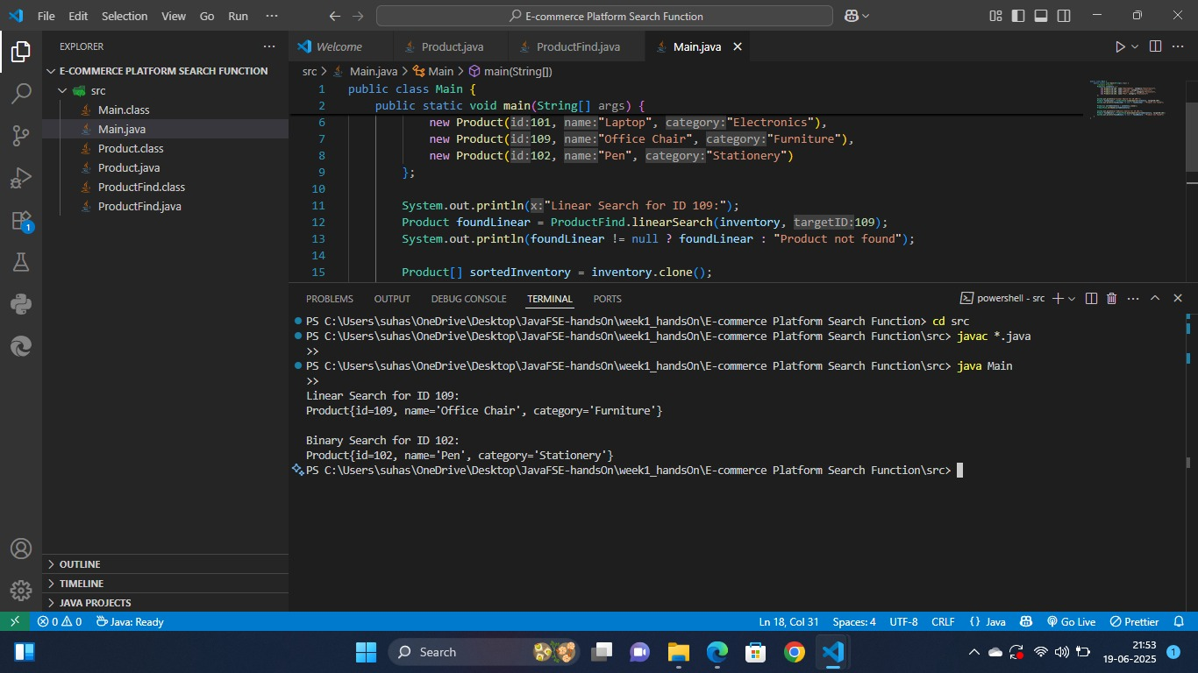E-Commerce Platform Search Function (OUTPUT):